Q1: Which of the lattice planes illustrated in the figure (blue anions and red cations are properly scaled) represent a {110} plane in a stable cesium chloride structure?

Cesium Chloride structure resembles the BCC. Therefore, it is B.

* A
* **B**
* C
* D

Q2 Which is the proper notation for the crystallographic direction shown in the unit cell in the figure?

in direction, in direction, in direction

]

* []
* **[]**
* []
* []

Q3: What is shown in red in the unit cell in the figure?

The two below answers can be discarded, as the above answers would also apply if they were correct.

There are -½ on x, there’s -1 on y and 1 on z. So, it’s one of the {211} planes.

* **One of the {211} planes**
* One of the {221} planes
* A (121) plane
* A (212) plane

Q4: Praseodynium has a molar mass of , its atoms have a radius of . What is the density of -praseodynium, which crystallizes with body-centered cubic lattice?

* About
* About
* **About**
* About
* About

Q5: The graph shows the repeating unit of polychloroprene.

Compare a batch of polychloroprene (CR) with a batch of polybutadiene (BR) having the same molar mass. Which statement is correct?

1,3-Butadiene

No branching… If same molar mass, then Butadiene must have higher degree of polymerization, since lower average molar mass. It probably also has a lower glass temperature, because of its lower average molar mass, and because the Chloride atom in polychloroprene adds rigidity.

* CR has a higher degree of polymerization and a higher glass transition temperature than BR.
* Cr has a higher degree of polymerization than BR, but BR has a higher glass transition temperature than CR.
* BR has a higher degree of polymerization and a higher glass transition temperature than CR.
* **BR has a higher degree of polymerization than CR, but CR has a higher glass transition temperature than BR.**

Q6: An increase in crystallinity of a semi-crystalline polymer causes a reduction of…

When a semi-crystalline becomes more crystalline, it becomes less amorphous! Therefore, it becomes less transparent as well!

* …its yield strength.
* … its melting temperature.
* **… its transparency.**
* … its degree of polymerization.

Q7: Semi-crystalline polypropylene cannot have a crystallinity much higher than 80%. Why?

Amorphousness arises from open spaces between the chains.

* Because the polymer chains must be folded and cannot be arranged in perfect order.
* **Because even a perfectly ordered arrangement will have open space between the chains.**
* Because the hydrogen atoms are making up 14% of the entire mass.
* Because polypropylene always shows atactic sections along the chain.

Q8: The density of polyethylene depends on its crystallinity. Amorphous regions with mass density are less dense than crystalline regions with . What is the density of semi-crystalline polyethylene with a crystallinity of 70%?

Q9: At room temperature, a nickel specimen contains the equilibrium vacancy concentration. The specimen is heated to a temperature just below the melting temperature and - after establishing thermal equilibrium - quenched. Compared to the original specimen, the quenched specimen is…

Quenching is the rapid cooling of a workpiece in water. It works by reducing the grain size of the metal, increasing its strength.

* … a better electrical conductor.
* **… stronger.**
* … slightly larger.
* … stiffer.

Q10: When the Young’s modulus of a material depends on the loading direction, the material is…

Wikipedia: “ An anisotropic object or pattern has properties that differ according to direction of measurement. For example many materials exhibit very different properties when measured along different axes: [physical](http://localhost:3000/wikipedia_en_all_maxi_2023-10.zim/A/Physical_property) or [mechanical properties](http://localhost:3000/wikipedia_en_all_maxi_2023-10.zim/A/List_of_materials_properties#Mechanical_properties) ([absorbance](http://localhost:3000/wikipedia_en_all_maxi_2023-10.zim/A/Absorbance), [refractive index](http://localhost:3000/wikipedia_en_all_maxi_2023-10.zim/A/Refractive_index), [conductivity](http://localhost:3000/wikipedia_en_all_maxi_2023-10.zim/A/Electrical_resistivity_and_conductivity), [tensile strength](http://localhost:3000/wikipedia_en_all_maxi_2023-10.zim/A/Tensile_strength), etc.).”

* …anelastic.
* **…anisotropic.**
* …allotropic.
* …auxetic.
* …atactic.
* …amorphous.

Q11: Which lattice defects can cause a higher stiffness?

The Young’s modulus (E) is a measure of stiffness. The higher it is, the higher the stiffness.

Dislocations lower E. Same thing with greater amount of grain boundaries. Also same with pores.

But Interstitial atoms can limit the movement of the atoms of the lattice, resulting in higher stiffness.

* **Interstitial atoms**
* Dislocations
* Grain boundaries
* Pores

Q12: Compare the stress strain curves from two specimens A and B as shown in the figure.

Which statement is correct?

B has **same stiffness** as A, same elastic modulus

A is **stronger** than B, higher yield strength,

B is **more** **ductile** than A, higher strain of fracture

B is **tougher** than A, bigger area under curve.

* Specimen B is stiffer than specimen A.
* Specimen B is stronger than specimen A.
* Speciment B is less ductile than specimen A.
* **Specimen B is tougher than Specimen A.**

Q13: Large plastic deformation of aluminium leads to substantial changes in several of its properties. Which change does NOT arise as a consequence of plastic deformation by compression?

Ductility DOES decrease. Strength DOES increase. Density DOES increase. But electrical conductivity increases if anything, due to higher density.

* A decrease in ductility.
* An increase in strength.
* **A decrease in electrical conductivity.**
* An increase in density.

Q14: Two molybdenum specimens have rather different yield stresses (1680 MPa and 300 MPa) due to their different grain sizes ( and ). Which grain size will cause a yield stress of 600 MPa in molybdenum?

Strength as a function of grain size:

Expression for as :

*Ligningen løses for k_y vha. WordMat.*

Expression for as :

*Ligningen løses for k_y vha. WordMat.*

Setting the two expressions for equal each other and solving for :

*Ligningen løses for σ_0 vha. WordMat.*

Finding by one of the expression for it and the newly found value for :

At last, solving the equation:

*Ligningen løses for D vha. WordMat.*

* About
* **About**
* About
* About

Q15: Compare the properties of binary alloys formed by two completely miscible metallic elements with the properties of the two pure elements. Which statement is correct? There exists always an alloy composition for which the binary alloy has…

Higher mass density - FALSE: This should be an average of the two components…

Higher compliance - FALSE: Compliance is inverse of stiffness.

Lower melting point - FALSE: A eutectic point only occurs in a phase diagram when there is limited solubility in the solid state. For example, the completely miscible copper-nickel system has NO eutectic points.

Lower ductility - TRUE: Different atoms create lattice distortions, impeding dislocation motion, reducing the ability of the material to deform plastically… Thus, lowering the ductility.

* …a higher mass density than both elements.
* … a higher compliance than both elements
* … a lower melting point than both elements
* **… a lower ductility than both elements.**

Q16: Molybdenum and tungsten are completely miscible in each other. Which defects are responsible for the superior strength of some of the alloys compared to the pure elements?

Interstitial atoms - FALSE: Since they are completely miscible, they should be similar in size and none of them comparatively small enough to fit into the other’s interstitial sites.

Substitutional atoms - TRUE: Because completely miscible and similar atomic size, can substitute each other in crystal lattice => lattice distortions due to slight differences in atomic size and electron structure => impeding dislocation motion, strengthening the material.

Phase boundaries - FALSE: They are completely miscible and thus form single solid phase across entire composition range, NO phase boundaries.

Small particles - FALSE: Not typical in completely miscible system.

* Interstitial atoms
* **Substitutional atoms**
* Phase boundaries
* Small particles

Q17: Molybdenum and tungsten are completely miscible in each other. Which of the three primary types of atomic bonds (metallic bonds, ionic bonds, and covalent bonds) are present in binary molybdenum-tungsten alloys?

Still delocalized electrons, thus solely metallic bonds.

Metallic bonds form between metals.

Ionic bonds form between metals and non-metals.

Covalent bonds form between non-metals.

* **Solely metallic bonds.**
* Metallic bonds and ionic bonds.
* Metallic bonds and covalent bonds.
* Metallic bonds, ionic bonds and covalent bonds.

Q18: The semiconductor InSb crystallizes in the zinc blende (ZnS) structure. The table summarizes some properties of the elements.

What could be the reason for the zinc blende structure?

Ionic fraction is really f’ing low!

Zinc blende favors covalent bonding !

* The similar ratio between the atomic radii of In and Sb.
* The large difference in electronegativity between In and Sb.
* The dominating ionic bonding in InSb.
* **The dominating covalent bonding in InSb**.

Q19: The ionic ceramics CaS, CuI, KBr, and TlCl show distinctively different crystal structures and fractions of ionic bonding. The table summarizes the properties of the elements.

Which of the four compounds crystallizes in sodium chloride structure (rock salt structure) and has the smallest fraction of ionic bonding?

REMEMBER TO ONLY USE IONIC RADIUS!!!

Sodium Chloride

For Ca+2 S -2:

SMALLEST IONIC FRACTION!

For Cu+2 I-1:

NOT NaCL

For K+1 Br -1:

For Ti+1 Cl-1:

* **CaS**
* CuI
* KBr
* TlCl

Q20: The tensile strength of a ceramic material becomes higher, …

* **Porosity**: Increasing porosity typically reduces the tensile strength of ceramics because pores act as stress concentrators and crack initiation sites.
* **Temperature**: Increasing temperature generally reduces the tensile strength of ceramics because thermal expansion can induce microcracks and lower the material's cohesive forces.
* **Mass Density**: Increasing the mass density of a ceramic generally indicates fewer pores and better compaction, leading to higher tensile strength.
* **Grain Size**: In ceramics, smaller grain sizes often lead to higher tensile strength due to the grain boundary strengthening mechanism (Hall-Petch relationship). Increasing grain size usually decreases tensile strength.
* … when the porosity is increased.
* … when the temperature is increased.
* **… when the mass density is increased.**
* … when the grain size is increased.

Q21: The figure shows the phase diagram of the binary alloy system magnesium-nickel (). No changes occur between and room temperature.

A melt of a magnesium-nickel alloy with is cooled slowly from to room temperature. How many different solid phases of the four solid phases (Mg), , , , and (Ni) in the phase diagram are formed at some instant during the solidification process?

It goes through ALL except Ni (Check at both sides of the line!).

* 1
* 2
* **3**
* 4

Q22: The figure shows the phase diagram of the binary alloy system magnesium-nickel (). No changes occur between and room temperature.

A melt of a magnesium-nickel alloy with is cooled slowly from to room temperature. What is the lowest Ni content possible in the melt during solidification?

Go to the left! The lowest composition of in the MELT (liquid phase L) is

* 0 wt.%
* **22.1 wt.%**
* 49.8 wt.%
* 52 wt.%

Q23: The figure shows the phase diagram of the binary alloy system magnesium-nickel (). No changes occur between and room temperature.

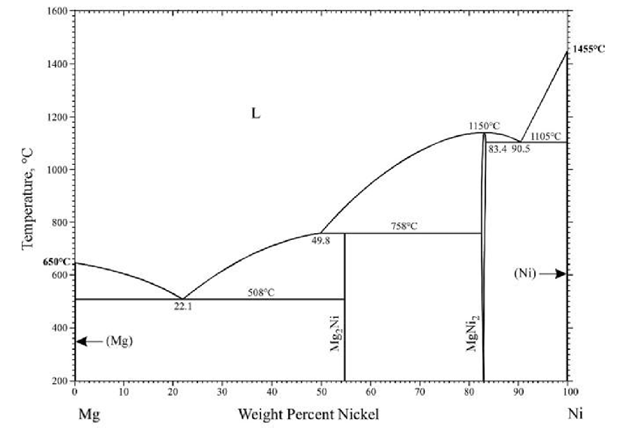

A melt of a magnesium-nickel alloy with 95% wt.% Ni is cooled slowly from to room temperature. What is the mass of (Ni) for a melt of 3.5 kg?

We classify as right, and as left, and calculate :

Then, we multiply this phase fraction onto the melt weight of 3,5 kg:

* About 1.0 kg
* About 1.5 kg
* About 2.0 kg
* **About 2.5 kg**
* About 3.3 kg

Q24: The figure shows the phase diagram of the binary alloy system magnesium-yttrium (Mg-Y). The lines end at room temperature.

Does the phase diagram contain eutectic points?

A eutectic point is known to constitute a lower melting point than both of the constituents of the alloy. So, indeed there is one at 24,0 wt.% Y!

* Yes, one at for
* **Yes, one at for**
* Yes, several for different temperatures and compositions
* No, there is no eutectic point

Q25: The figure shows the phase diagram of the binary alloy system magnesium-yttrium (Mg-Y). The lines end at room temperature.

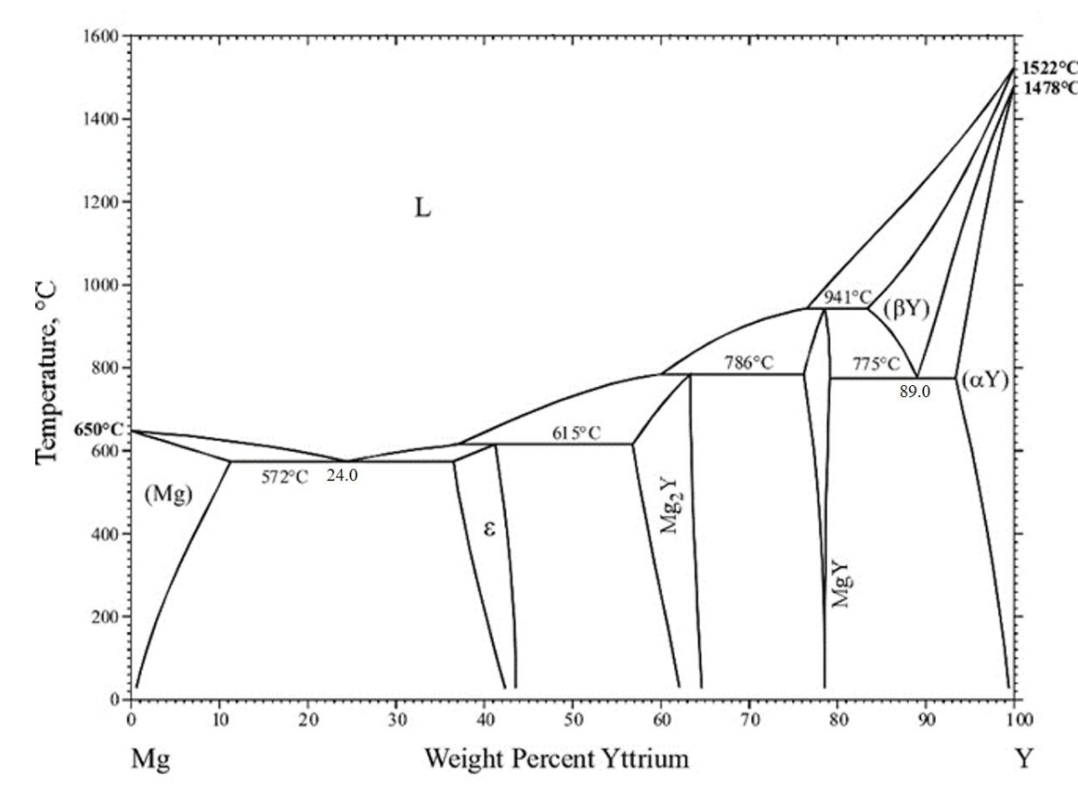

Solid phases of yttrium

What is the maximum solubility of Mg in solid yttrium?

We know that it’s Y, but we need the wt.% for Mg:

Therefore, it’s .

* About 7 wt.% Mg
* About 11 wt.% Mg
* **About 16 wt.% Mg**
* About 84 wt.% Mg
* About 89 wt.% Mg
* About 93 wt.% Mg

Q26: The figure shows the phase diagram of the binary alloy system magnesium-yttrium (Mg-Y). The lines end at room temperature.



A melt of a magnesium-yttrium alloy with 70 wt.% Y is cooled slowly from to room temperature. Which is the first solid phase formed?

Look to the right of the line! They are looking for the SOLID phase. So DO NOT include (+L).

* **MgY**
* MgY + L
* + L
* (-Y)
* (-Y) + L

Q27: The figure shows the phase diagram of the binary alloy system magnesium-yttrium (Mg-Y). The lines end at room temperature.



A melt of a magnesium-yttrium alloy with Y is cooled slowly from to room temperature. Which microstructure is present at room temperature?

Since it is a eutectoid point, all of the phase is transferred into two new ones, that is NO pro-eutectoid points!

* **Solely a eutectoid structure with alternating lamellae of MgY and**
* A eutectoid with alternating lamellae of MgY and (-Y) and additionally pro-eutectoid ().
* A eutectoid with alternating lamellae of MgY and (-Y) and additionally pro-eutectoid ().
* A eutectoid with alternating lamellae of MgY and (-Y) and additionally pro-eutectoid (MgY).

Q28: The figure shows the phase diagram of the binary alloy system magnesium-yttrium (Mg-Y). The lines end at room temperature.

Compare the properties of four specimens with different compositions: specimen A is pure Mg, specimen B is a magnesium-yttrium with 5 wt.% Y, specimen C is a magnesium-yttrium alloy with 20 wt.% Y and specimen D is a magnesium-yttrium alloy with 40 wt.% Y. Which statement is correct at ?

* Specimen A is the strongest
* Specimen B is the softest.
* Specimen C is the most ductile.
* **Specimen D is the most brittle.**

Q29: In the aircraft industry, aluminium-polymer composites are used to reduce the effect of cracks. Consider the five-layer laminate composite illustrated in the figure made of three thick layers of an aluminium alloy and two thick layers of a polymer. The table summarizes the properties of the materials

What is the elastic strain of the laminate along the loading direction when a compressive stress of 200 MPa is applied perpendicular to the layers?

* Less than 0.31%
* At least 0.31%, but less than 0.36%
* At least 0.36%, but less than 0.41%
* **At least 0.41%, but less than 0.46%**
* At least 0.46%, but less than 0.51%

Q30: Consider the five-layer laminate composite illustrated in the figure made of three thick layers of an aluminium alloy and two thick layers of a polymer. The table summarizes the properties of the materials

The aluminium-polymer lamellar composite shall replace an aluminium alloy plate of same height (1,3 mm). During service, the aluminium alloy plate is loaded in compression along its height to the maximum load it can endure without deforming plastically. Does the lamellar composite or, alternatively, a pure polymer plate of same height constitute a lightweight alternative to the aluminium alloy plate?

It is loaded until !!

* Yes, both, the lamellar composite and a polymer plate can substitute the aluminium alloy plate with less weight.
* Yes, the lamellar composite can substitute the aluminium alloy plate with less weight, but the polymer plate cannot...
* Yes, the polymer plate can substitute the aluminium alloy plate with less weight, but the lamellar composite cannot.
* **No, neither the lamellar composite, nor the polymer plate constitute a lightweight alternative to the aluminium alloy plate.**

Q31: Consider silver with an electrical conductivity of . A silver wire that is 20 cm long is subject to the requirement that the voltage drop should be 3 V when a current of 1 mA passes through it. What should the diameter of the wire be?

*Ligningen løses for r vha. WordMat.*

* 75 nm
* 450 nm
* **1.2**
* 52

Q32: Lead is a face-centered cubic material with a unit cell length of . Assume there is one conduction electron per unit cell and an electrical conductivity of . What is the drift velocity of the electrons in a field of ?

Q33: The electrical conductivity of a certain ZnTe device is measured to be . The electron and hole mobilities of ZnTe are and , respectively. What is the intrinsic carrier concentration for ZnTe at room temperature?

Q34: Polyethylene foam is a good thermal insulator. Which of the following statements does NOT provide a valid explanation for this property?

If porous, then more air pockets = good thermal insulator, air poor conductor of heat

Amorphousness disrupts propagation of phonons (vibrational energy), reducing thermal conductivity.

Thermal conductivity is proportional to electrical conductivity in all materials. Less propagation of electrons = less thermal conductivity

* Polyethylene is porous
* Polyethylene foam is not crystalline, and phonons cannot easily propagate.
* Polyethylene foam is not metallic and electrons cannot easily propagate.
* **Polyethylene foam has a low heat capacity and cannot store heat.**

Q35: A cubic lunch box with six sides of equal area ( each) contains ice to keep the temperature at . The box is placed in a room with a constant temperature of . The thermal conductivity of the lunch box material is and the container is everywhere thick. Assuming steady state heat flow, what is the heat loss rate (that leads to melting of the ice)?

Distance of wall to travel through:

Surface of lunch box:

Change in temperature:

Thermal conductivity constant:

Power required (Fourier’s law):

* **8,6 kJ/min**
* 92 kJ/min
* 144 kJ/min
* 242 kJ/min

Q36: Consider the image and the histograms.

Which of the histograms shown corresponds to the image?

Most dark (low intensity), middle gray, least white (high intensity). Therefore 5.

* 1
* 2
* 3
* 4
* **5**

Q37: Consider the small original image below with a size of 15 x 15 pixels.

Which of the five options given is the result of median filtering the original image with a median filter of size 5 x 5 pixels?

Median filtering blurs the original. There are more dark than light pixels in the original, so it should become darker. Therefore 4.

* 1
* 2
* 3
* **4**
* 5

Q38 Consider a 3D image of a material consisting of two phases with a distinct interface between them. The image has 400 x 400 x 400 voxels and a voxel size of x x . In the same image, the interface area between the two phases present is measured to be . What is the volume specific interface area between the two phases?

Q39: Consider modeling the temperature distribution in a metal rod as a 1D heat transfer problem using the heat equation. At one end of the metal rod the boundary condition is used. What is the type and the physical interpretation of this boundary condition?

Neumann condition, change in heat is 0 normal to the boundary.

* **A Neumann boundary condition describing an insulating boundary.**
* A Neumann boundary condition describing a boundary with a set temperature of .
* A Dirichlet boundary condition describing an insulating boundary.
* A Dirichlet boundary condition describing a boundary with a set temperature of .
* A Laplacian boundary condition describing an insulating boundary.
* A Laplacian boundary condition describing a boundary with a set temperature of .

Q40: Consider modeling the temperature distribution in a rod of metal as a 1D heat transfer problem using the heat equation. The rod is 1 m long. The two ends of the rod are defined at (point A) and (point B). The initial temperature in the rod is with the following boundary conditions:

Point A: .

Point B:

In the steady state solution, what is the temperature at

* A steady state solution does not exist.